**------------------------------Assignment1 ------------------------------**

**Tasks To Be Performed:**

1. Install MS SQL Server

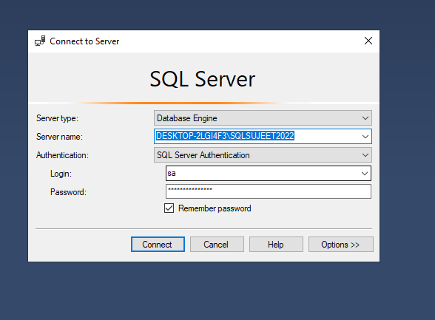

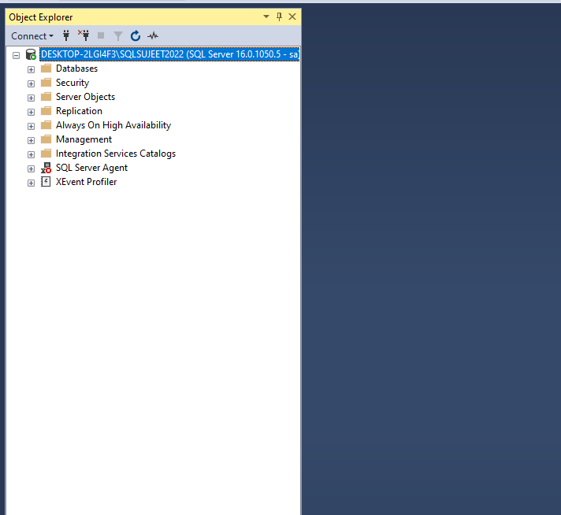

1. Give the difference between Char and Varchar data type.

Ans: name

Char:

1. char allocates the same no of spaces to all the data given irrespective of their length.
2. CHAR datatype is used to store character strings of fixed length.

Example: gender char(1)

Varchar:

1. varchar allocates variable spaces as according to the word length
2. VARCHAR datatype is used to store character strings of variable length

Example: Name varchar(20)

1. Explain the types of SQL Commands.   
     
   DDL(Data Defination Language):

* Create: Create statement is use to create an object which is not present in our sql server i.e creating database,table,sp,function,trigger etc.

Example :- Create database database name

Create table table_name (columns_name datatype,………….)

* Alter :- Alter statement is use to modify the object which is present in our MS SQL Server I.e table,function,sp etc.

Example: Alter table table_name alter column column_name datatype

Alter table table_name add column column_name datatype

* Drop :- Drop statement is use to delete an object which is present in our MS SQL Server I.e database,table,function,sp etc.

Drop database database_name

* Truncate :- Truncate statement is use to delete the entire data without any condition from a table without affect the structure of the table.

Truncate table table_name

DML(Data Manupulation Language)

* Insert: Insert statement is use to insert a new data into the table.  
    
  Example:   
    
  Insert into table_name values  
  (data ,……….),
* Update: Update statement is use to update the data present in table.

Example:

Update table set column_name = value where condition.

* Delete: Delete statement is use to delete a particular data which user want to delete

Example :

Delete from table_name where condition.

DQL(Data Query Language)

* Select : Select statement is use to fetch the data out of the memory.

Example: Select column_names from table_name

1. Explain NVarchar and Nchar.

Ans: NVarchar and Nchar is same as varchar and char datatype but varchar and char datatype can hold only english data it cann’t hold regional data so we use NVarchar and Nchar to hold regional data.

Example:

Create table test(name nvarchar(20))

insert into test values('सुजीत')

insert into test values(N'सुजीत')

Output

?????

सुजीत